EE316 – Digital Logic Design
Dr. Nina Telang
Final Exam
Name:____________________

- Read the entire exam first.
- Show all your work.
- Be neat – I need to be able to read your work.
- Aim for an A+
- Relax!!! ☺



Thank You for being such a wonderful class! I thoroughly enjoyed teaching this course.

- Problem # 1 ________________/15

- Problem # 2 ________________/10

- Problem # 3 ________________/5

- Problem # 4 ________________/10

- Problem # 5________________/10

- Problem # 6 ________________/10

- Problem # 7 ________________/8

- Problem # 8 ________________/12

- Problem # 9 ________________/10

- Problem # 10 _______________/10
- This problem concerns the design of a serial adder/subtracter with accumulator for 4-bit numbers as shown below. [15 points]

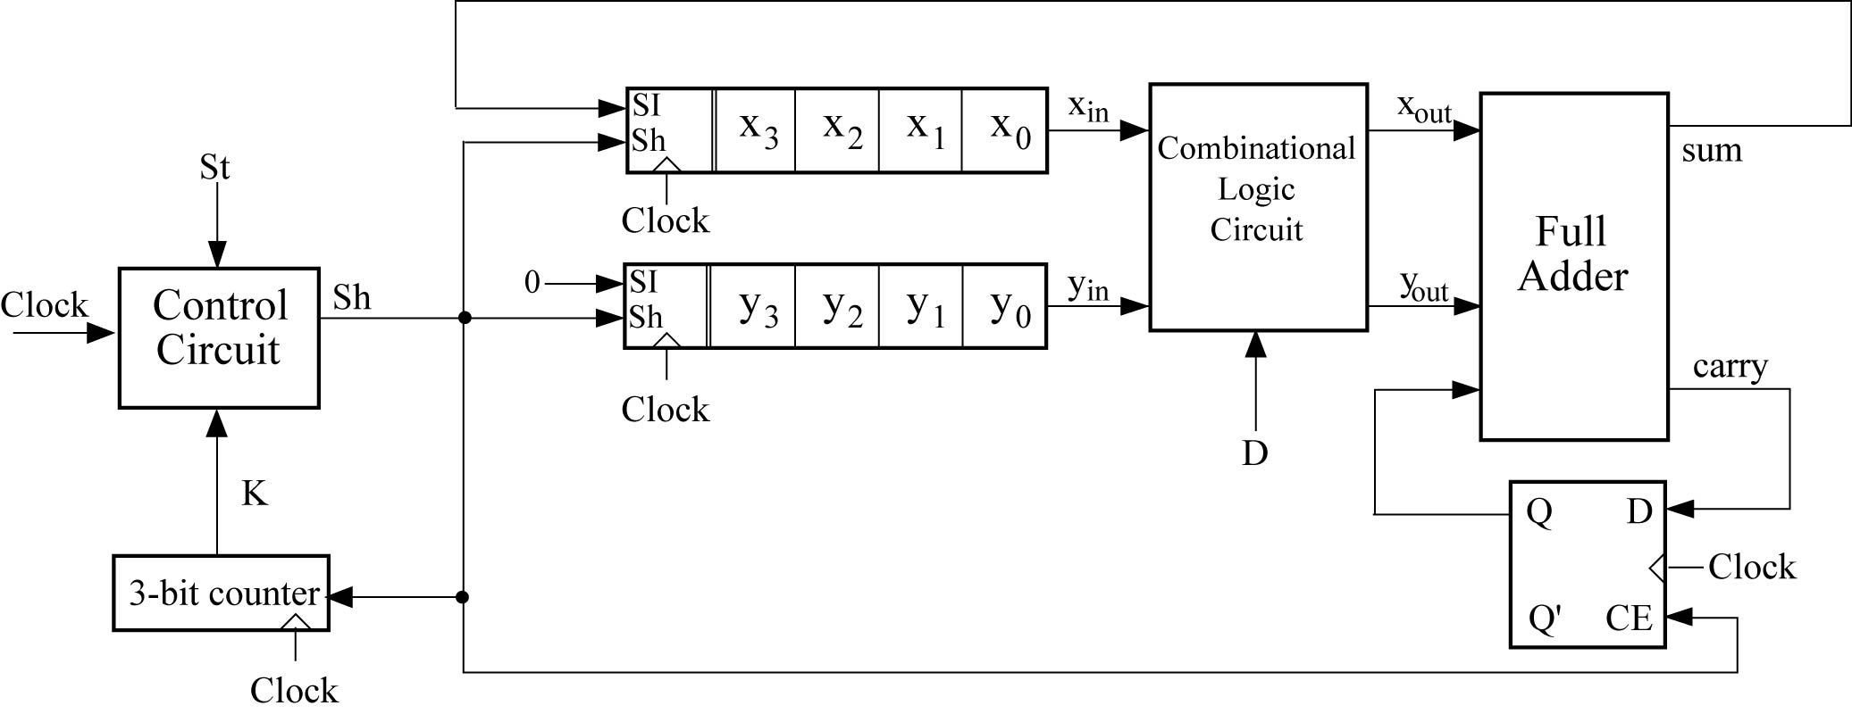

The combinational logic circuit has an input D which determines whether addition or subtraction will take place. When D = 1, the contents of registers X and Y are added together. When D = 0, the contents of registers X and Y are subtracted (i.e., X – Y). The control circuit has one output (Sh) and two inputs — a start signal St and a counter output signal K. The counter counts the number of shifts, and outputs a signal of K = 1 when it is 111 (after 7 shifts). Assume that D is not changed during the operation of the adder/subtracter. Assume negative numbers are represented in 1's complement. Subtraction should be done by adding the 1's complement. Note that 8 shifts are required: 4 to do the initial addition and 4 more to add on the end-around carry.

(a) Construct a state graph for the control circuit (3 states). The operation should begin when St is set to 1. St may be 1 for one clock cycle, or it might remain 1 for many clock cycles, even after the addition is completed. Make sure that the circuit does not begin again after it is finished. The start signal must be changed back to 0 to reset the control circuit.
(b) Design the control unit using D flip-flops and any kinds of gates.
(c) Design the combinational logic circuit.

- Complete the behavioral VHDL model for the bidirectional shift register shown below. The CLRb is asynchronous and overrides all other inputs. All other state changes occur on the rising edge of CLK. If S0=S1=1, the register is loaded in parallel. If S0=0 and S1=1, the register is shifted right and SDR is shifted into Q3. If S0=1 and S1=0, the register is shifted left and SDL is shifted into Q0. If S0=S1=0, no state change occurs. [10 points]
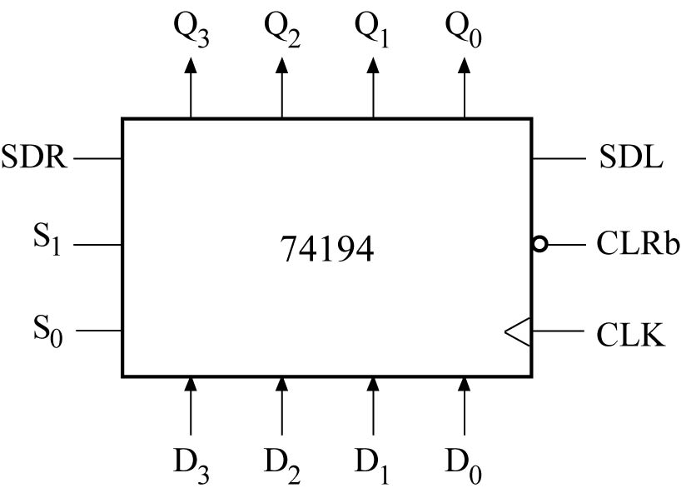

entity chip74194 is
Port(CLRb, S1, S0, SDR, SDL, CLK:in std_logic; D:in std_logic_vector(3 downto 0); Q:out std_logic_vector(3 downto 0));
end chip74194;
architecture behavior of chip74194 is
signal Qint:std_logic_vector(3 downto 0);
begin
Q <= Qint;
process(CLRb,CLK)
begin

end behavior;

- Reduce the following state table to a minimum number of states. [5 points]

present next state output
state X=0 X=1 X=0 X=1
A A E 1 0
B C F 0 0
C B H 0 0
D E F 0 0
E D A 0 0
F B F 1 0
G D H 0 0
H H G 1 0

- For the following table: [10 points]
(i) State the three guidelines which are useful in making state assignments. For the state table and assignment #1 given below, which of these guidelines are satisfied?
(ii) For the given state table and state assignment #1, derive the input equations for the D flip-flops and derive the output equations for Z.

present next state output
state x=0 x=1 x=0 x=1
A D C 0 0
B B B 0 0
C E A 1 0
D B E 0 0
E A D 1 0

State | State Assignment 1  (Q₁Q₂Q₃) | State Assignment 2  (Q₁Q₂Q₃)
A | 000 | 100
B | 101 | 010
C | 110 | 001
D | 100 | 000
E | 001 | 110

- A sequential circuit has one input (X) and two outputs (Z₁ and Z₂). An output Z₁ = 1 occurs every time the input sequence 100 is completed, provided that the sequence 010 has never occurred. An output Z₂=1 occurs every time the input sequence 010 is completed. Note that once a Z₂=1 output has occurred, Z₁=1 can never occur but not vice versa. Find a Mealy graph and table.
[10 points]

- For the given network:
[10 points]

a) Construct a transition table and a state graph.
- Construct a timing chart for the input sequence X = 10101. Indicate at what times Z has the correct value and specify the correct output sequence. (Assume that X changes midway between clock pulses.) Initially, Q1 = Q2 = 0.

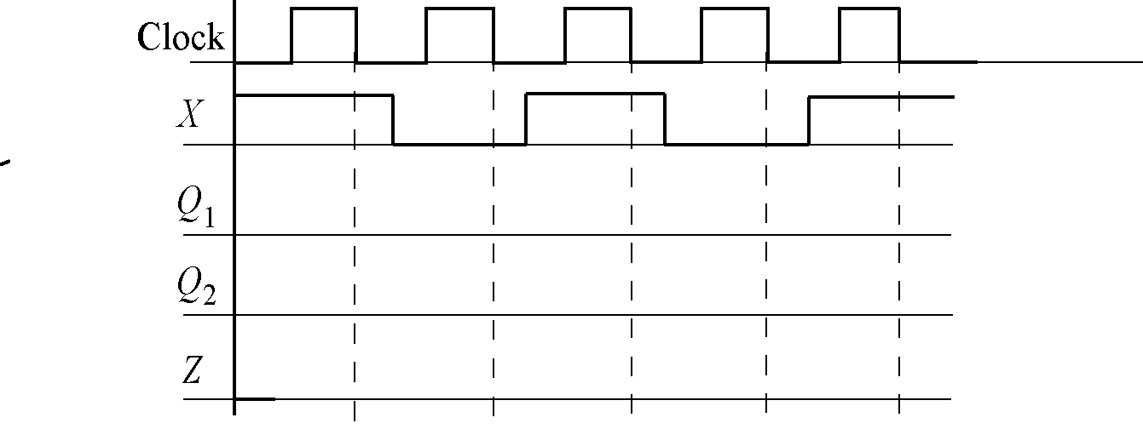

- A Y-Z flip-flop behaves as follows: [8 points]

If YZ = 01, the flip-flop does not change state.
If YZ = 11, the flip-flop is set to Q = 1.
If YZ = 10, the flip-flop changes state.
The input combination YZ=00 is not allowed.
a) Derive the characteristic equation for the Y-Z flip-flop.
b) Complete the table below using don't cares where possible.

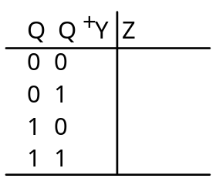

- Solve the following: [12 points]
(i) Simplify to obtain a sum of 3 terms of the form XXX + XXX + XXX.
(A ≡ B') (C ⊕ B') + ABCD

(ii) Simplify: (answer should be a sum of 3 terms)
(X ≡ Y) + (X ⊕ Z)(X'+ Y)

(iii) Without using a truth table, prove that
(X ⊕ Y) ≡ (X ⊕ Z) = Y ≡ Z

- For the following function: [10 points]
f(X,Y,Z,W) = ΠM (4,6,8,10,14)
(i) Design a minimum two-level NAND-NAND circuit
(ii) Convert the circuit from part (a) to a two-level OR-NAND circuit
(Do not use gate symbols with input bubbles in your final answer.)

- Given the following 3-to-8 line decoder and a NAND gate, show the necessary connections so F = AC + AB’ [10 points]
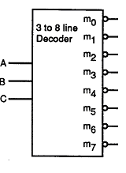

[Extra paper]

